[Lambda (amazon.com)](https://us-east-1.console.aws.amazon.com/lambda/home?region=us-east-1#/begin)

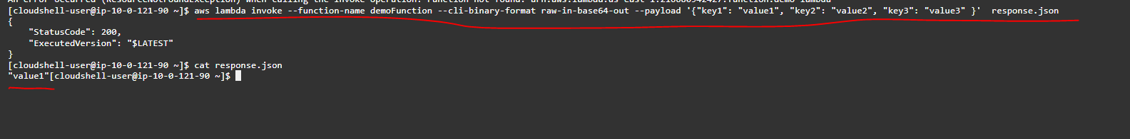

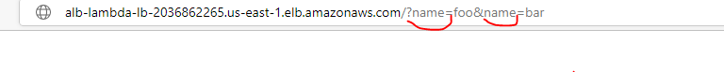

Lambda & CloudWatch Events / EventBridge Hands On

